Team –

I have discovered a way of finding every object in the FAS application. I have been using the dynamic find method. I have used it to successfully find each of the buttons in FAS (there are three different types) and the items in the Tree View. I have them listed below:

**private** **void** clickObject(String string) {

// Clicks a button that is not a ThunderRT6CommandButton or a .Pushbutton

// The string parameter is the recognition property .name

RootTestObject root=RootTestObject.*getRootTestObject*();

TestObject[] matchingObjs=root.find(*atProperty*(".name", string),**false**);

System.*out*.println(matchingObjs.length);

**if**(matchingObjs.length>0) {

((GuiTestObject) matchingObjs[0]).click();

}

*unregister*(matchingObjs);

}

**private** **void** clickTreeObject(String string) {

// Clicks a TreeView object that has as its recognition properties .class=TreeView20WndClass

// The string parameter is the full path to the item (e.g., Payments->One Time Payment (06A) )

RootTestObject root=RootTestObject.*getRootTestObject*();

TestObject[] matchingObjs=root.find(*atProperty*(".class","TreeView20WndClass"));

System.*out*.println(matchingObjs.length);

**if**(matchingObjs.length>0) {

System.*out*.println(matchingObjs[0]);

((GuiSubitemTestObject) matchingObjs[0]).click(*atPath*(string));

} *unregister*(matchingObjs);

}

**private** **void** clickSearchObject(String string) {

// Clicks a button that has as its recognition properties .class=ThunderRt6CommandButton

// The string parameter is the recognition property .name

RootTestObject root=RootTestObject.*getRootTestObject*();

TestObject[] matchingObjs=root.find(*atList*(*atProperty*(".class","ThunderRT6CommandButton"),*atProperty*(".name",string)));

**if**(matchingObjs.length>0) {

((GuiTestObject) matchingObjs[0]).click();

} *unregister*(matchingObjs);

}

**private** **void** clickPushButton(String string) {

// Clicks a button that has as its recognition properties .class=.Pushbutton

// The string parameter is the recognition property .text

TestObject[] to=*find*(*atDescendant*(".class",".Pushbutton",".text",string), **false**);

((GuiTestObject) to[0]).click();

*unregister*(to);

}

Here are some examples of use:

clickTreeObject(“Payments->One Time Payment (06A)”);

This will click on the highlighted item. 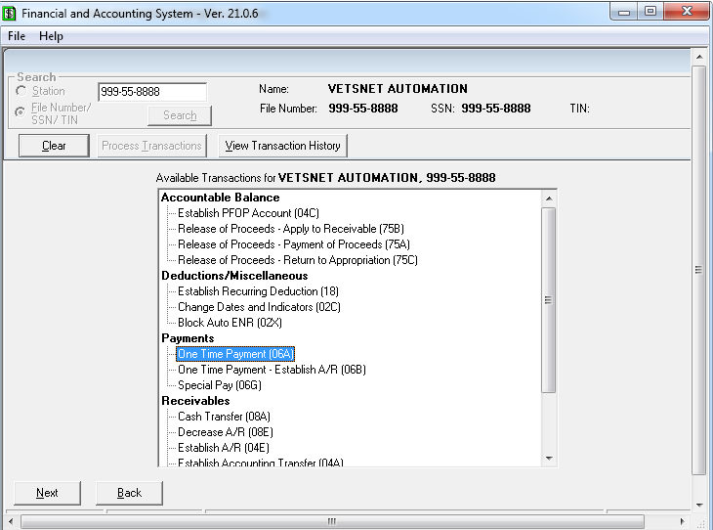

clickSearchObject(“Search”);

This clicks the search button that is of type ThunderRT6CommandButton 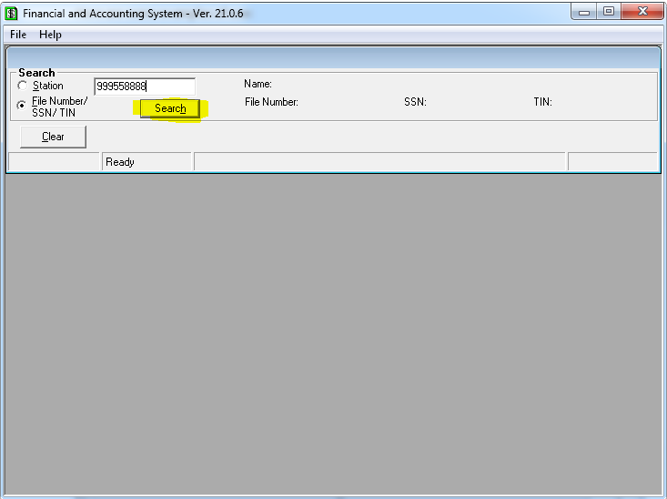

You can tell what type of button using the Test Object Inspector 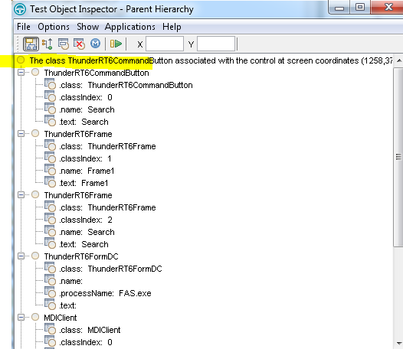 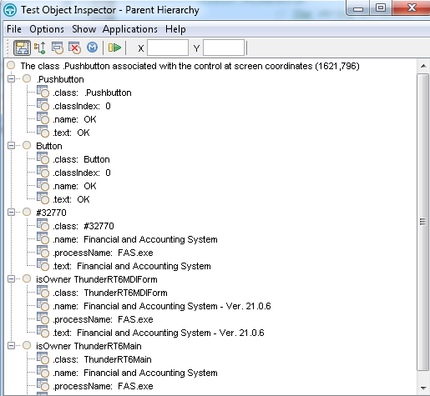

You can find and click this object with the clickPushButton(“OK”); command.

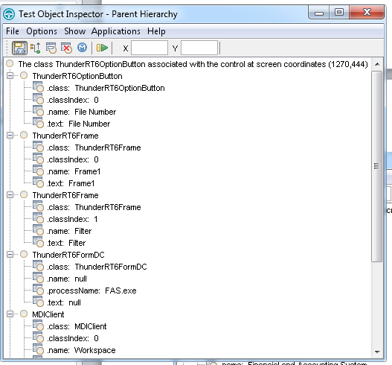

You can find and click this option button with the clickObject(“File Number”); command.